CS 501 Project Report

Jonathan Fishkin, Bhavya Shah

We decided to do Final Project IV as our choice for the final project. As for the three problems, we chose 3 problems from Chapter 15: questions 28, 29, and 32 and added a few extra modifications. We organized our folder by having each problem be its own .java file, with a ProjectMain.java that compiles it together. This project uses JavaFX to create a visual with animations.

The ProjectMain file runs the project with all the problems inside. After starting the project, it will have 3 radio buttons to click on, each corresponding to a specific application. In order to see the solution, you must click on one of the radio buttons, which will in turn disable the others. To see another one, you must deselect the current radio button corresponding to the running application, and then select another radio button.

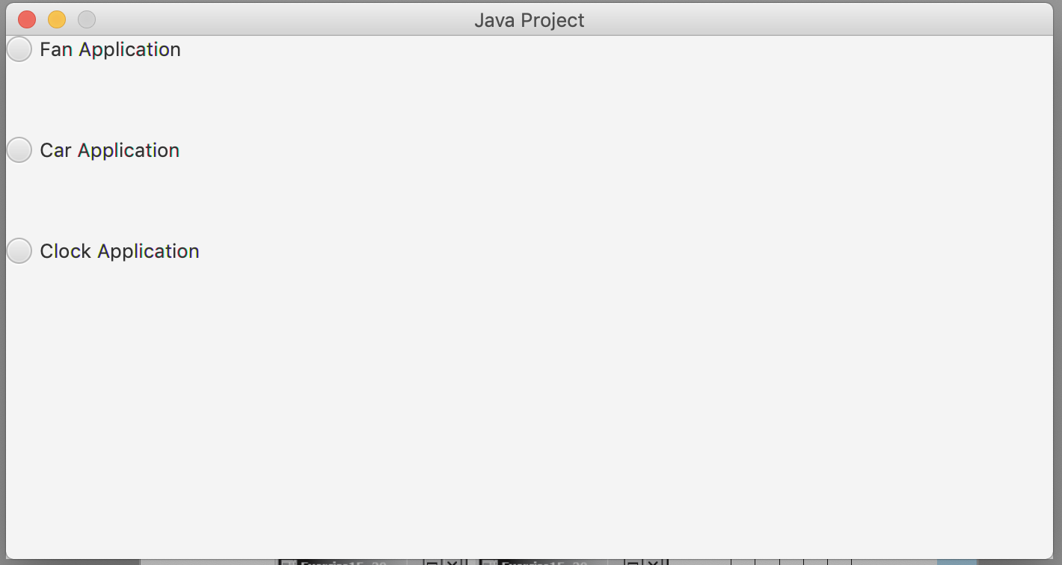

The first problem is question 28, or the fan problem. This creates a fan that rotates at a constant speed. Two buttons allow you to pause the rotation and restart. The reverse button allows you to reverse the direction the blades are spinning, and the “Random Color” button changes the color of the blade.

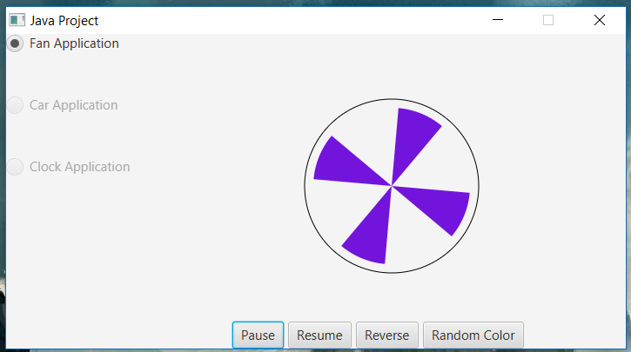

The second problem is question 29, or the car problem. This shows a car that is at rest to start. As you hold down the right arrow button, it will continue to speed up, the text will change to show that it is speeding up, and the car will change color to green. When the left arrow held down, the reverse will happen: the car will slow down and the text will state that it is slowing down, If the car halts to a stop, then the color of the car will change to red.

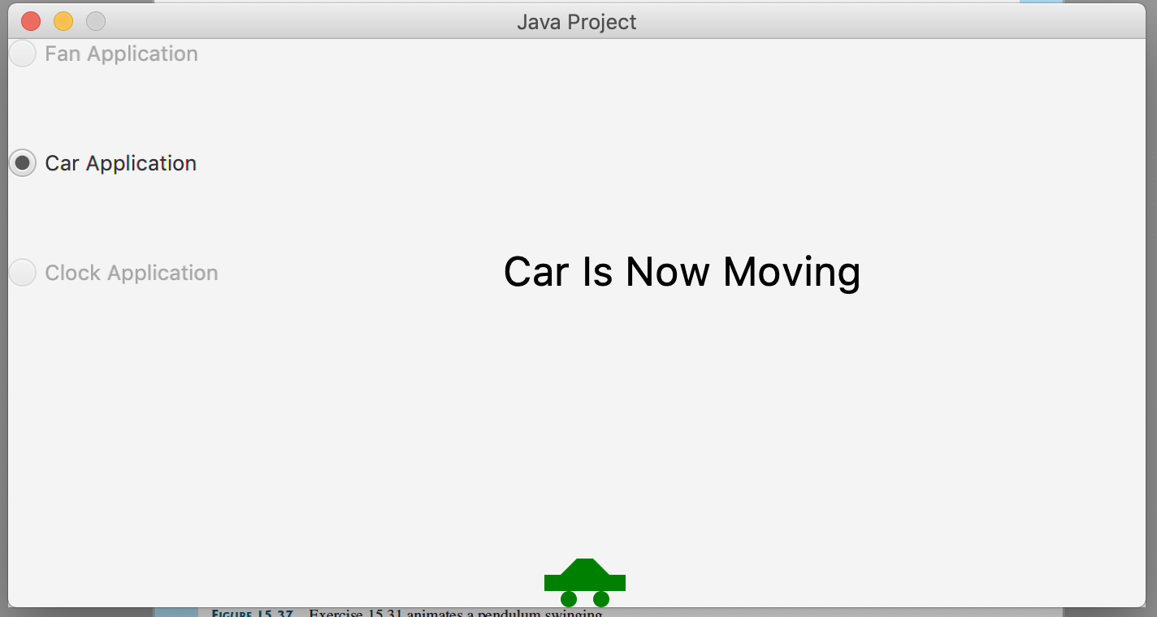

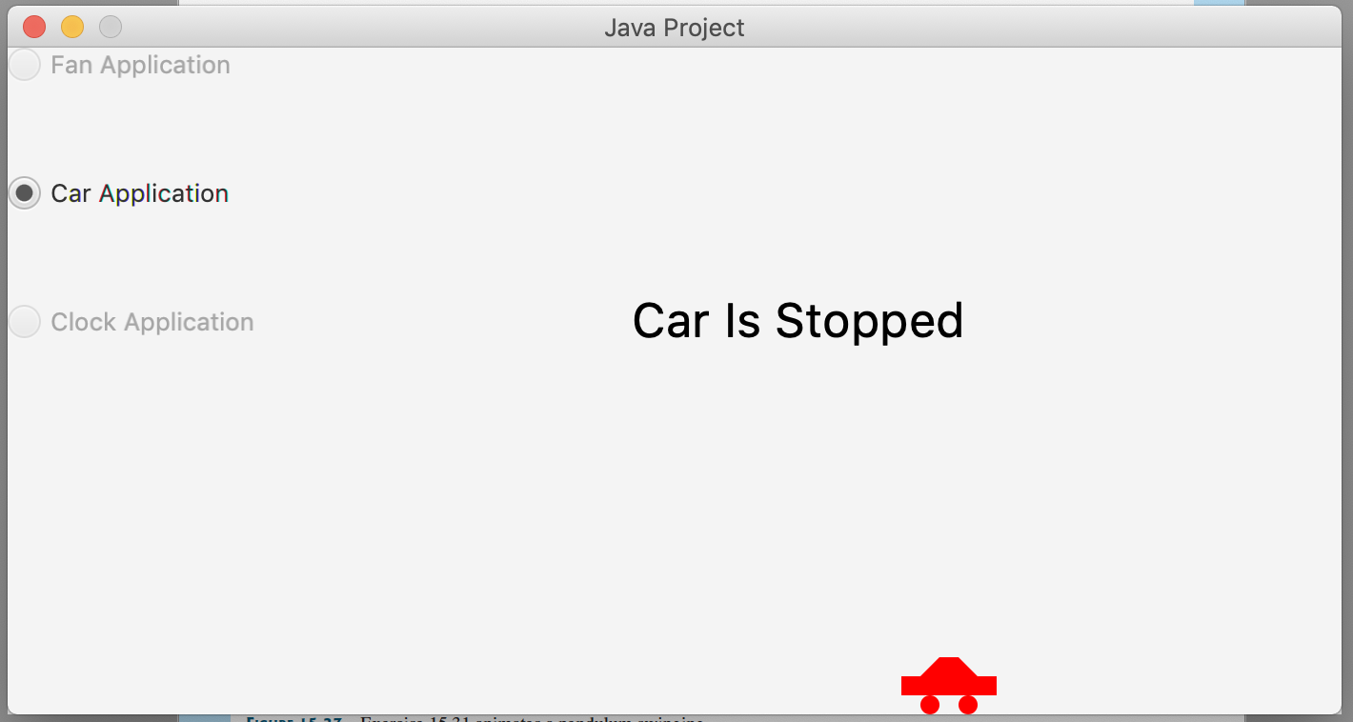

The third problem is question 32, or the clock problem. This shows a clock with the current time. It also has two buttons, Start and Stop, which start and stop the clock. Starting the clock again will edit the time to the new current time.

